

Bangladesh University Of Business and Technology (BUBT)

Advanced Programming Lab
Course code: CSE 332
Lab Assignment 3

Submitted by:
Name: Anayat Hossain
ID: 21225103161
Section: 04
Intake: 49

Github Link:
https://github.com/AnayatHossain/Java-Lab-Assignment-3

Submitted to:
Md. Mahbubur Rahman
Assistant Professor, Dept. of CSE, BUBT
1. Write a Java program to show SIngle Inheritance.

Code:

class Animal {
void eat() {
System.out.println("Animal is eating");
}
}
class Dog extends Animal {
void bark() {
System.out.println("Dog is barking");
}
}
public class Main{
public static void main(String[] args) {
Dog obj= new Dog();
obj.eat();
obj.bark();
}
}

Output:

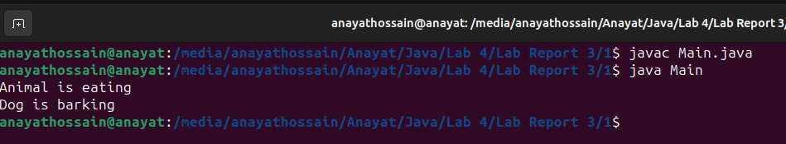
2. Write Java code to show multilevel inheritance.

Code:

class Grandparent {
void eat() {
System.out.println("Animal is eating");
}
}

class Dog extends Grandparent {
void bark() {
System.out.println("Dog is barking");
}
}

class Labrador extends Dog {
void play() {
System.out.println("Labrador is playing");
}
}
public class Main{
public static void main(String[] args) {
Labrador obj= new Labrador();
obj.eat();
obj.bark();
obj.play();
}
}

Output:

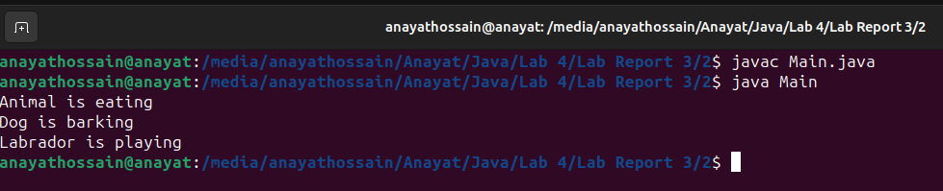
3. Write Java code to show hierarchical inheritance.

Code:

class Animal {
void eat() {
System.out.println("Animal is eating");
}
}
class Dog extends Animal {
void bark() {
System.out.println("Dog is barking");
}
}
class Cat extends Animal {
void meow() {
System.out.println("Cat is meowing");
}
}
public class Main{
public static void main(String[] args) {
Dog obj= new Dog();
Cat obj1= new Cat();
obj.eat();
obj.bark();

obj1.eat();
obj1.meow();
}
}

Output:

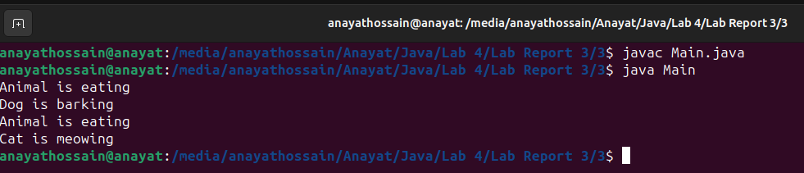
4. Write a Java code by combining SIngle, multilevel, and hierarchical in a single code.

Code:

class Animal {
void eat() {
System.out.println("Animal is eating");
}}
class Dog extends Animal {
void bark() {
System.out.println("Dog is barking");
}}
class Labrador extends Dog {
void play() {
System.out.println("Labrador is playing");
}
class Cat extends Animal{
void meow() {
System.out.println("Cat is meowing");
}}
public class Main{
public static void main(String[] args) {
Labrador obj= new Labrador();
obj.eat();
obj.bark();
obj.play();
Cat obj1= new Cat();
obj1.meow();
}}

Output:
